**Advanced Backend**

(This exercise uses the result of Chapter 6 Test)

1. **Create data grid by UiComponent**

* Remove all files related to DATA GRID you created for table “magenest_movie” in chapter 6 test.
* Create data grid for table “magenest_movie” using UiComponent (References: the internet)
* For the “rating” column: instead of showing its original data (e.g: 8/10), show a styled rating html, e.g:



1. **Customize an existing data grid**

* Add a column called “Odd/Even” to sales_order data grid (<magento_base_url>/admin/sales/order/)
* The column’s data contain one of the following: “Odd”, “Even” depends on the Order Id:
* If the Order Id number is an Odd number, show “Odd”
* If the Order Id number is an Even number, show “Even”
* Used Magento styled css (find the css class to apply to the data):
* A “critical” message (color red): for “Odd”
* A “notice”/”success” message (color green): for “Even”

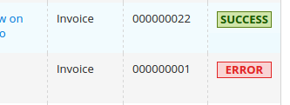

1. **Input data using UiComponent**

* Remove all files related to “create a new movie” form you created in chapter 6
* Create a form to input a new movie using UiComponent (again, references: the internet):
* Makes “name” a required field
* Rating is inputted as number, but you need to validate its data, must greater than 0
* “director_id” is not inputted as a number, create a select for this field, user can see the director’s name and choose the right director for the movie

1. **Create our own backend page**

* Create a blank page with Magento layout at backend.
* Create another section in your Menu (created in chapter 6), e.g of sections:

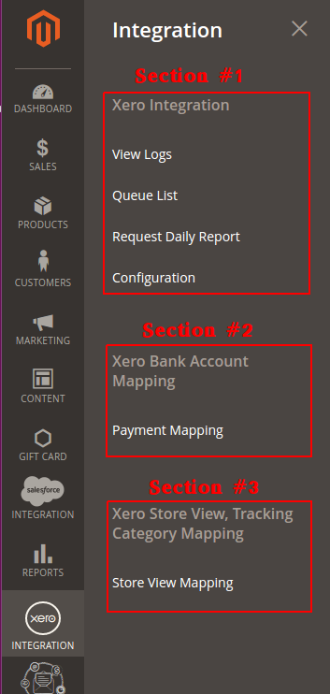

* Create a sub-menu-item that links to your page
* The Page’s content (see pic below):
* Magento already has css apply to all pages in backend, find the right css class (check out other Magento backend pages) to make it looks like the pic
* In the “1st content container”, show: Numbers of module installed in Magento, Numbers of module installed in Magneto but belonged to another Vendor (not Magento)
* In the “2nd content container”, show: Numbers of Customers, Products, Orders, Invoices, Creditmemos currently in Magneto.

